SEARFE v3.0 Software Installation Instructions for the Windows XP operating system

While logged in as an Administrator:

- Install the Java run-time environment (JRE).
  - Run j2re-1_4_1_01-windows-i586-i.exe

- Install Java 3D for Open GL (for graphics support).
  - Run java3d-1_2_1_04-win32-opengl-rt.exe

- Install the Spectrum Scanner software.
  - Extract the SpectrumScannerV3.0.zip to C:\Program Files. Note extracting the file will create the SpectrumScannerV3.0 directory.

- Make a shortcut to the C:\Program Files\SpectrumScannerV3.0\3.0\run.bat file and put it on the all users’ desktop (C:\Documents and Settings\All Users\Desktop). Rename the shortcut to Spectrum Scanner. Put a copy of the shortcut in the all users’ Start>All Programs menu (C:\Documents and Settings\All Users\Start Menu\Programs).

- Turn off the screen saver and set the power settings so the laptop stays on.
- click "Start>Control Panel"
- click "Appearance and Themes"
- click "Choose a screen saver"
- choose "None" from the list of screen savers.
- click "Power"
- set System standby to "Never" when the computer is plugged in
- set System hibernates to "Never" when the computer is plugged in
- the other settings should be alright.
- click "OK"
- click "OK"

Software Configuration

The software configuration options and default settings, such as location names and coordinates, are stored using the Java Preferences framework. These settings are stored in the registry at: My Computer\HKEY_CURRENT_USER\Software\JavaSoft\Prefs\rfss.

To edit the list of locations run regedit (by selecting Run… from the Start menu and typing regedit and pressing Enter in the Run window) and open the folder
My Computer\HKEY_CURRENT_USER\Software\JavaSoft\Prefs\rfss\data\options as shown:
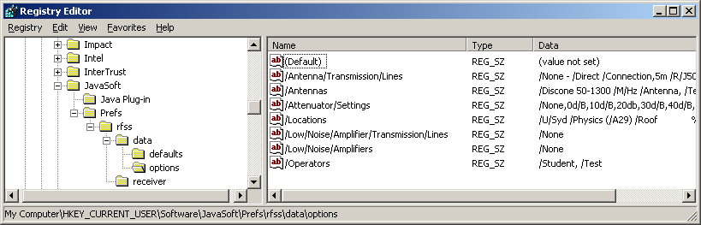

Double click /Locations to edit the locations key. Each location is stored in the form <LocationName> % <Longitude> % <Latitude> and each location entry is separated by a comma ‘,’.

The Spectrum Scanner application must be restarted in order for any changes in these settings to take effect. Note invalid settings may cause the software to behave unpredictably and function incorrectly. If this occurs, manually delete all the settings by selecting the
My Computer\HKEY_CURRENT_USER\Software\JavaSoft\Prefs\rfss folder and pressing the Delete key. Restarting the application after removing the settings will cause the program to recreate all the settings with their original values.

On Linux these settings are stored in xml files in the users’ ~/.java/userPrefs directory. The ~/.java/userPrefs/rfss/data/options/prefs.xml file can be edited to add additional locations using the same method described above. To delete all the settings use the command “rm –fr”.

