Students Exploring Australia's Radio Frequency Environment
Welcome to the SEARFE Project!

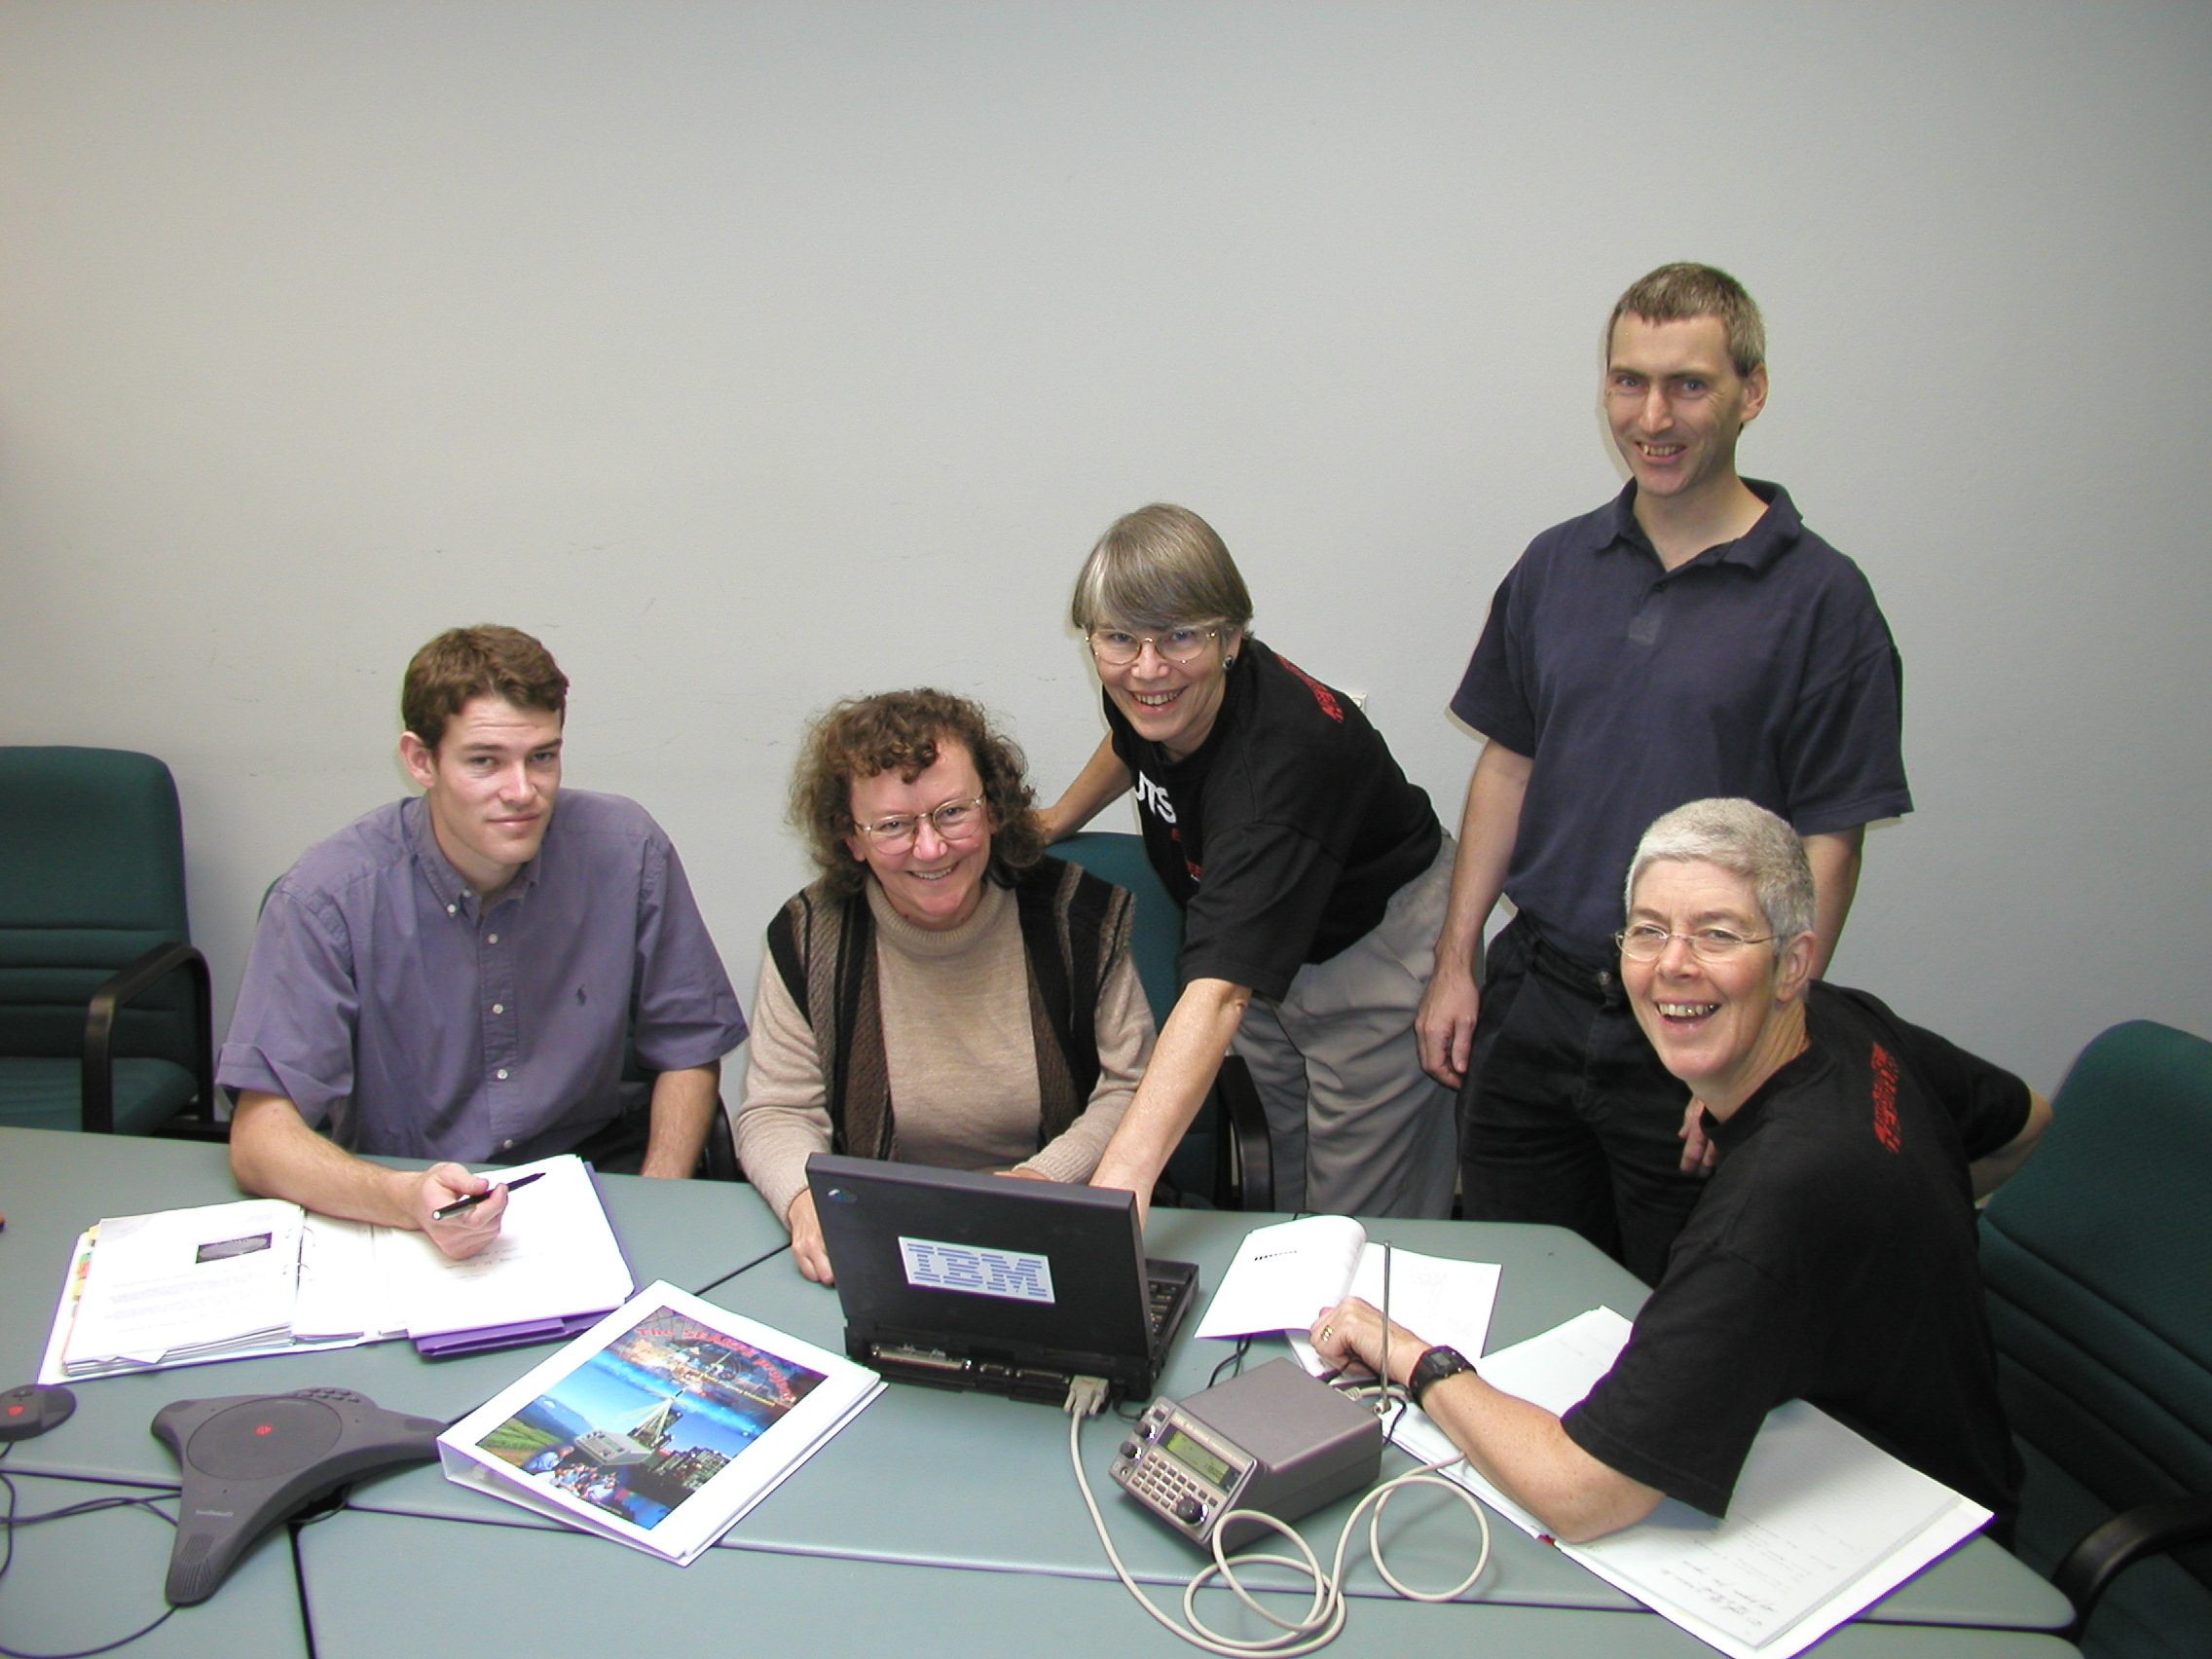
We are a team of scientists and engineers from CSIRO and Universities and we are
inviting you to get a taste of radio frequency science by becoming involved in this project.

You will have the opportunity to use modern equipment to measure the radio frequency intensities in your area. You will then analyse your data and share your findings with other students involved in the project using Internet and e-mail technologies.

We hope you can help us by developing your own experiments and we look forward to incorporating your own work in future releases of these guidelines.

Your work has the potential to contribute to our understanding of the actual use of the radio frequency spectrum in Australia and eventually to Australia’s chances of hosting the Square Kilometre Array, the most advanced radio telescope currently being designed by an international group of radio astronomers.

This is the first time that something like SEARFE has been attempted. This is research! We don’t yet know the answers, or the best method to use to find the information we seek. Thank you for participating in our search for new knowledge. Your contributions and feedback will be appreciated.

The SEARFE Team
Anne Green Project Leader
Michelle Storey Project Manager
Betty Jacobs Education and Documentation Co-ordinator
George 'Nyima' Warr Software Manager
Oliver Mather Software Engineer
Helen Sim Communications
Peter Hall Project Adviser
Duncan Campbell-Wilson Project Adviser

Other Team Members
Julienne 'Jules' Harnett
Vince McIntyre
Andrew Wright
Warren Yates

For more information contact
Dr Michelle Storey
Project Manager
Email: atnf-searfe-chat@csiro.au

