Using the Receiver and Antenna

To take part in the SEARFE Project you need to be able to use the equipment:
- The AR-3000A Receiver with its whip antenna
- The SEARFE software on the laptop
- The discone antenna.
The next activities take you through the steps to help you familiarise yourself with the SEARFE equipment.

NOTE: Although it is legal to tune in and listen to broadcast frequencies, for some frequencies it is not legal to act on any information received. Ask your teacher if you are not sure what is meant here.

1. Tuning to a local radio station using the receiver
Find out the frequency at which a local radio station transmits (e.g. 702 kHz is ABC in Sydney)
Follow the Easy Guide - Using the Receiver to tune it to the local station by the
- Direct tuning method
- Dial tuning method.
Practise using the receiver by trying to find a few more stations.

2. Scanning for a local radio station using the SEARFE software
Follow the Easy Guide – Using the SEARFE Software to scan across a range of frequencies (e.g. a 10 MHz range) near the frequency of your local radio station.
Your results will appear as graphs and will also be saved on your computer as a text file to use later.

One peak will represent the local radio station you were scanning for. You may be able to identify what other frequency peaks represent, either by tuning to each frequency with the receiver and listening, or by using resources such as the Australian Communications Authority database.

3. Tuning into a local TV channel
Both the Jaycar website and the Dick Smith Electronics website have data sheets available listing radio frequencies used by TV stations and other transmitters.
Find the frequency range being used by a local TV channel.
Use the Receiver and Software Easy Guides to set up and scan the bandwidth of the channel you are trying to find.
It is always advisable to check how long the scan you have programmed in will take.
Can you identify the various signals being broadcast?

You can check the sound carrier frequency by tuning to it with the receiver and then also tuning a TV set to the relevant channels. The sound tracks should be the same!

Experiment with using a smaller or larger frequency step to determine which step size gives you maximum useful information in minimum time.

Let us know what seems optimum for you, as this will help us all refine our experiments. Ask for advice using the SEARFE chat email when you need to.

4. Printing your results
Print your results using the Easy Guide – Printing a Scan. You can also import the saved files you have produced in these activities into an Excel Spreadsheet.

5. Positioning your antenna
The next important step is to understand how to use your antennas most effectively. The AR-3000A Receiver comes with its own Whip Antenna, and you also have a Discone Antenna. Background Notes on Antennas contain basic information on how antennas work and how the discone antenna in particular functions. The discone antenna comes with its own set-up instructions, there are also some helpful hints in the Guide – Assembling the Discone Antenna.

It is important to position the antenna as far away as possible from sources of local interference. You will need to experiment with different positions of the antenna to try and find the best location. Possible initial investigations are suggested below. Please email your findings via SEARFE chat. Your results will be important for other team members and future SEARFE students. Through your results we can learn about likely sources of interference and how to avoid them.

For the radio-quietness scans in the next set of activities it will probably be best to locate the discone antenna outside and as high as possible. Perhaps a school maintenance person can mount the discone somewhere high and isolated using the mounting brackets provided. Again please email us with ideas and your findings of the best mounting locations. Pictures especially welcome!

Possible initial investigations to explore best antenna positioning.
a. Use the whip antenna.
Position the receiver near your computer
Set up a short scan from 50-200MHz at a frequency increment of 0.5 MHz.
Store the resulting graph

b. Detach the whip antenna
Attach it to the 10 metre coaxial cable supplied.
Attach the other end of the cable to the receiver.
Position the antenna near the receiver and laptop but make sure it does not touch either of them.
Set up the same scan as in (a).
Store the resulting graph.

c. Position the antenna as far from the receiver and laptop as possible, in various locations.
Set up the same scan as in (a).
Store the resulting graph.

d. Set up the Discone antenna as far from the receiver as possible using the instructions supplied.
Set up the same scan as in (a).
Store the resulting graph.

Compare the graphs to find any effects you can detect with distance from sources of em radiation (like computers and power cables) and length of aerial cable.

Do you experience significant loss of signal strength when using the long cable?

Experiment with the Discone antenna to find the best location for it to be mounted.

Radio Spectrum Use

The purpose of the SEARFE Project is to find out how much of the radio-frequency spectrum is being used, and for what fraction of the time, at various locations around Australia. In this activity we would like you to explore the radio frequency spectrum in your local area by taking various scans over different frequency ranges at different times of the day and hopefully different times of the year.

We would like you to take some scans spanning the range of frequencies 300 MHz to 1 GHz. However, we suggest that you take some shorter scans first and begin to build up a picture of where the radio quiet regions of spectrum are in your local area, and at what time of day they are radio-quiet.

Communicate your results on spectrum use to students at other schools and to the SEARFE scientists using the SEARFE data website.

We don’t know what you will find so cannot give specific advice on what you should try. We will all learn as we progress – very much the nature of real research.

Use the Easy Guides to remind you how to use the equipment.
1. Quick scan for radio spectrum use in your area
- Set up the scan
- Remote
- WFM
- 100-300 MHz frequency range
- 0.2 frequency increment
- 50 extra dwell time
- 2 scans
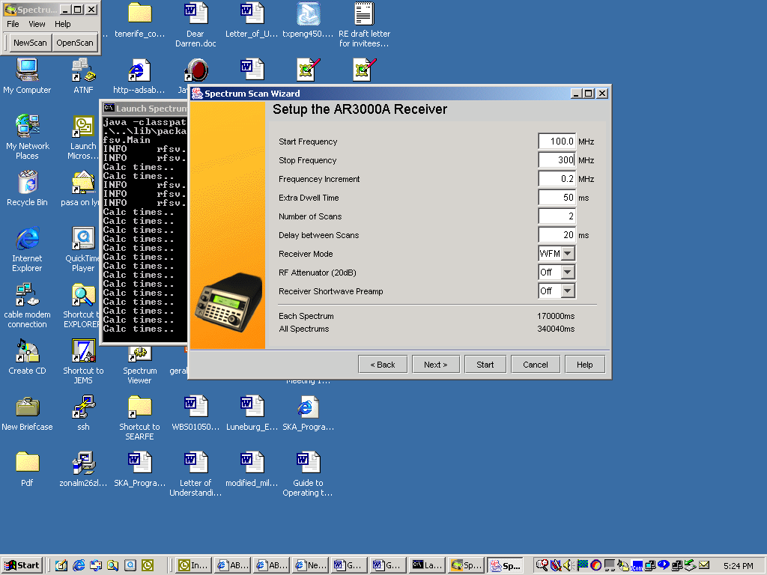
How long will this scan take?
Create a graph and examine the radio quiet areas on your graph.
What happens if you look at quiet areas with a more detailed scan?

2. Whole spectrum scan for radio spectrum use in your area
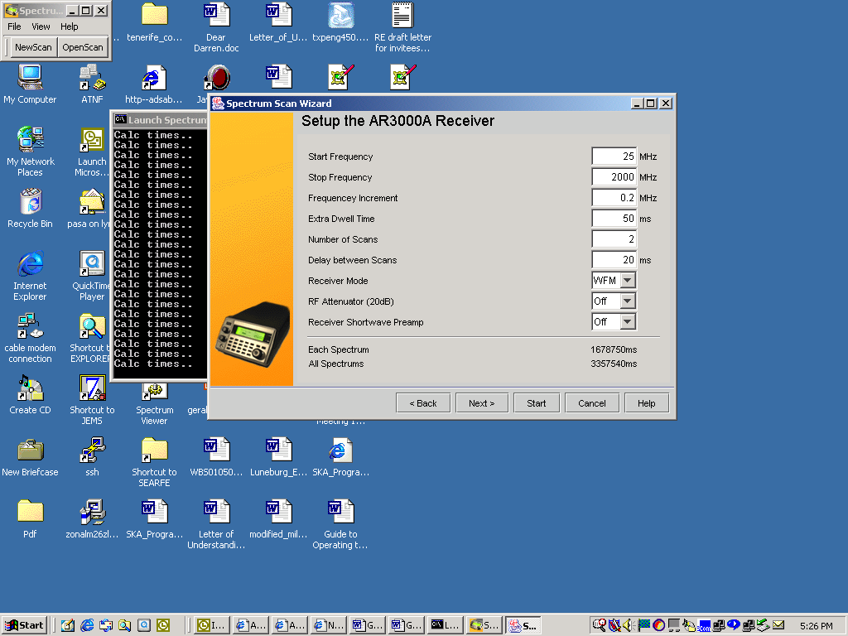
Set up the scan, eg using the input values below.

How long will this scan take?
Examine the radio quiet areas on your graph.

3. Working with the SEARFE Research Team
When you have results that you are happy with, upload your results to the SEARFE website using the SEARFE data exchange following the instructions you will find there.
Look at the results of other areas in Australia.
What are the similarities and differences?

Email other researchers with your comments and questions about the team results, their similarities and differences using SEARFE chat.

This has begun your research as part of the Australia wide research team to examine radio spectrum use and radio quietness in Australia.

Now you need to investigate what happens at different times of the day, different days of the week, different times of the year.
Remember to be consistent so all the results can be compared.

To be true scientific research your investigation must be standardised across all teams, controlled, reproducible and well documented. You need to consider the controls that will make data from your team comparable with data from the other teams.

Please send your ideas to SEARFE chat so that we can ensure that our results are the best they can be. SEARFE Mentors will work actively with you on developing the best experiments for your area.

Keep in touch and have fun!

