Science with the Square Kilometre Array telescope

The study of the stars has captured the imagination of humankind for tens of thousands of years. Even in our modern, visually exciting world, most people find the dark night sky an awe-inspiring sight. Astronomy satisfies a deep-seated human wish to understand more about our place in the universe.

To search deeper and deeper into space we need larger and more sophisticated telescopes to measure the light and other radiation from distant objects in the universe. The Square Kilometre Array telescope (SKA) will be one of these telescopes. It will be a radio telescope, detecting and processing radio waves rather than light.

The diagram below highlights science that will be possible with the SKA. The SKA will be able to look simultaneously in more than one direction, indicated by the several beams directed at different cosmic objects. It will also be able to minimise the impact of radiation from man-made sources such as radio communications transmitters and strong nearby satellites.

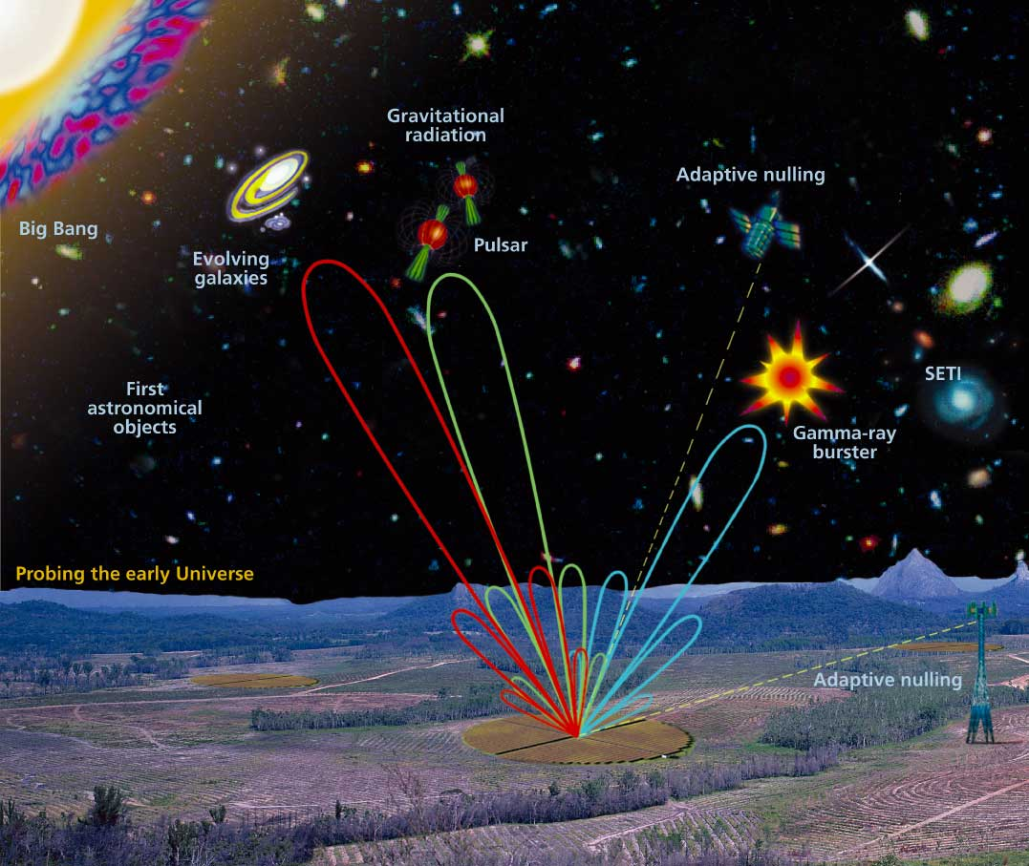

The following gives an overview of some of the key fields of investigation that work with the SKA will focus on in order to obtain a deeper understanding of the universe.

1. Probing the Early Universe
The SKA will be able to detect very weak radiation. This means that it will be able to study galaxies that are very distant from us. The radio waves emitted from these galaxies have travelled for a long time to get to us, so when we study this radiation we are seeing galaxies as they existed long ago. We think that the universe emerged in a “Big Bang” explosion roughly 14 billion years ago, which created all space, matter and energy. As matter from the Big Bang expanded and cooled it began to form lumps, which then evolved into galaxies and stars. Using the SKA astronomers will be able to see radio-waves that have come from these first structures of the very early universe and will be able to answer fundamental questions about how the universe evolved.

2. Exploring cosmic structures
Because the SKA will see very faint objects in fine detail it will enable major advances to be made in many areas of radio astronomy. Some examples are given below.

Dark Matter. Matter can be detected through its gravitational pull, and measurements of gravitational effects on objects in space indicate that there is vastly more matter in space than just the matter that we can “see” from the radiation it emits. This is the so-called Dark Matter. The SKA will give more information on the way galaxies move, and thus on the Dark Matter in these galaxies. This will help us to learn how much matter there is in the universe.

Gravitational waves. Pulsars are tiny spinning stars with a very precise spin rate. The spin rate is altered when a gravity wave passes by the pulsar. The SKA will be able to time a number of pulsars to accuracies of better than a microsecond, and so will be able to detect gravity waves, the ripples in the overall geometry of space produced by moving objects. One cause of gravity waves is thought to be pairs of giant black holes orbiting each other. Black holes are the most compact form of matter, and the gravitational pull of a black hole is so great that, on its surface, not even light can escape. Finding gravity waves will help confirm that these black hole pairs exist.

Search for Extraterrestrial Intelligence (SETI). The SKA could conduct searches for intelligent life elsewhere in the universe with a sensitivity up to 100 times greater than is now possible, and will be able to detect any Jupiter-size planets orbiting stars near our solar system.

Space tracking. The SKA will be able to simultaneously track many satellites and space probes, and detect and track asteroids, including those which may get dangerously close to the earth in the future.

Gamma-ray burst sources. Intensely powerful explosions producing bursts of very high-energy radiation called gamma-radiation have been recently observed. The SKA will be able to follow the life of these massive explosions, which are now thought to produce black holes. It will be the only instrument in the world able to see the fine details of what is happening in these explosions.

3. Discovering the Unexpected
Scientists have predicted the experiments they will be able to perform for the first time with the SKA. They believe they will solve many current mysteries with the new telescope. However, history has taught scientists that such innovative new equipment as the SKA makes unexpected new discoveries that radically change our view of nature. We expect the SKA to fundamentally change our understanding of the universe.

