Radio Astronomy and the
Square Kilometre Array telescope (SKA)

What is radio astronomy?
Radio astronomy uses radio waves to study objects in space, in a similar way to the way that optical telescopes use light to study objects in space. Stars, galaxies and other cosmic objects give out radio waves as well as light and other radiation. The radio waves tell us about the size, shape and behaviour of the object being studied, what it is made of, and what lies in the space between it and the Earth. Radio telescopes receive and concentrate the radio waves, which are then electronically processed so that they can be measured by a computer, and then interpreted by astronomers.

What is the SKA?
The SKA, or Square Kilometre Array telescope, is the ‘next-generation’ radio astronomy telescope that scientists are planning for and designing. With an area for collecting radio waves of roughly one square kilometre, the telescope will have approximately 100 times the collecting area of the current largest radio telescope. However, the huge collecting area will not be in the form of a single antenna receiving the radio waves: instead, the waves will be collected by many small antennas, and then electronically combined. The optimum design and spacings for the individual antennas have not yet been decided.

What will the SKA look like?
The favoured design for the SKA has as its basic ‘building block’ a close-packed group of small antennas covering an area about 100-200 metres in diameter, and probably no more than 10 metres high. Such a group is called an ‘array-station’.

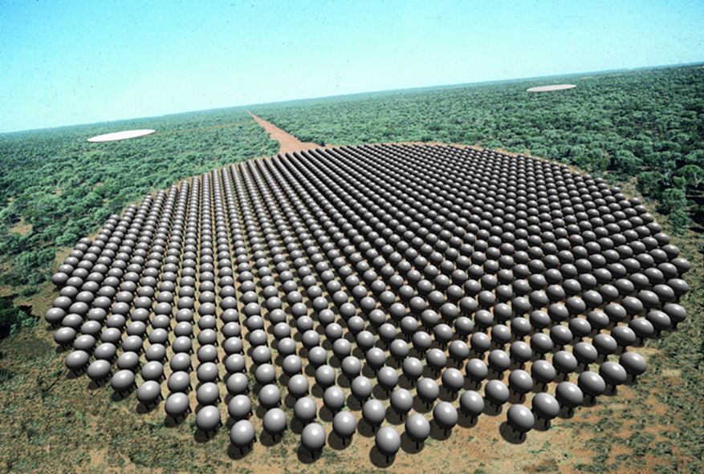
One possible design for the Square Kilometre Array, in which the individual
elements that collect the radio waves are 5-m diameter spheres (Luneburg lenses),
grouped into patches a few hundred metres across. The whole telescope consists
of many patches, some separated by hundreds of kilometres.
Image: Ben Simons, Sydney Vislab

The design of the individual antennas has not yet been finalised. The whole SKA will be made up of many sparsely scattered array-stations, possibly up to 1000, depending on the conclusions of design studies currently under way. About half the array-stations will be clustered together in a central site of about 50 km by 50 km. The others will be spread over a larger distance, perhaps as much as 2 000 km from the central site.

What will the SKA do?
The SKA will detect the radio waves from distant objects in space, enabling astronomers to answer many important questions about the Universe. Because the SKA will have approximately 100 times the collecting area of the current largest radio telescope it will be 100 times better than today's telescopes at detecting very weak signals. It will also be able to form much more detailed pictures of astronomical objects.

For example, because it will be such a sensitive instrument, one of the many new things the SKA will be able to do is to ‘see’ very distant objects. The radio waves from very distant objects have had to travel for a long time before they reach the Earth, and so the radio waves we measure from such objects were emitted a long time ago. The SKA will be so sensitive that it will be able to detect radio waves that were emitted when the Universe was still very young and very different to how it is now. The SKA will be able to explore the early history of our Universe.

When and where will the SKA be built?
Astronomers plan to design and build the SKA over the first two decades of the 21st century. The location for the SKA will be decided by the international astronomy community by 2006.

Current investigations of possible sites for the SKA in inland Australia are being jointly carried out by the CSIRO Australia Telescope National Facility and State Governments. The aim is to determine if suitable sites are available, before Australia prepares a case to put to the international community.

