Participating in the SEARFE Project

By participating in SEARFE, you can help in the search for radio-quiet sites in Australia. Australia is a good candidate host country for the Square Kilometre Array telescope, a $1 billion international radio telescope that a consortium of radio astronomy organisations from eleven countries is designing and planning for. Your results will help the SKA scientists and engineers learn about radio-frequency usage patterns around Australia, to help identify the best potential sites for the SKA.

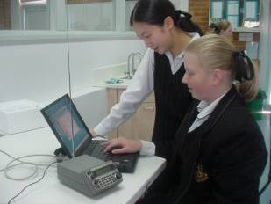

You will be equipped with a radio-frequency receiver, antenna and software and a full set of instructions. You will measure the levels of radio-frequency radiation in your neighbourhood and log the results. You will use the Internet to compare results, communicate with other students and scientists, resolve difficulties and suggest new experiments.

As well as the equipment required to undertake the investigations, Student Activities and Background Notes are provided in the Resource Kit. This will enable you to run the experiments and find out more about radio-frequency science, radio astronomy and the SKA telescope project. Some contact people (SEARFE mentors) are listed on the sheets and on the SEARFE website at http://www.searfe.atnf.csiro.au . These scientists/engineers have volunteered to help students with aspects of the project. If you have questions or comments, please contact these people through the SEARFE chat email on the website. With your feedback we can improve SEARFE for future students and all learn more as we progress through the experiments. Remember, in the search for new knowledge, no question is silly!
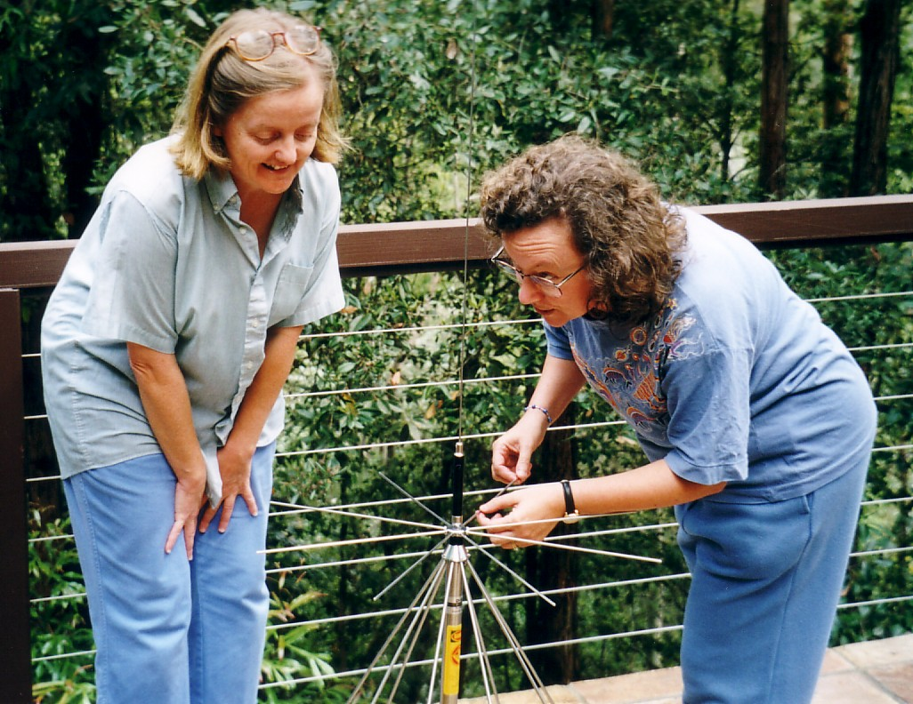
The Student Activities lead you through the steps needed to set up the equipment and perform basic investigations. The Background Notes provide further information on various topics. Please contact me or other SEARFE mentors through the SEARFE-chat email if anything is unclear of if you would like further information on any topics.

Before starting on SEARFE research, I suggest you read through the Student Activities, as much of the Background Notes as interest you, and have a look at the SEARFE website. Please subscribe to the SEARFE chat email group following the website instructions, and introduce yourselves by sending a message to SEARFE chat.

The SEARFE team look forward to hearing from you. We hope you enjoy your investigations with SEARFE.

Dr Michelle Storey

