Using the SEARFE Software

Set-up Procedure
- Connect the receiver to the computer using the 9 pin socket to 25 pin plug serial cable provided. The 25 pin plug connects to the back of the receiver and the 9 pin plug connects to the computer.
- Turn on the computer and the receiver.
- Turn the ‘Remote’ switch on the back of the receiver to ‘On’. This enables the receiver to be remotely operated via computer.
- Double-click the Spectrum Scanner shortcut icon on the desktop of the computer.
- Wait while the program loads (roughly 15 seconds). During this time a black MSDOS window may appear for some time.

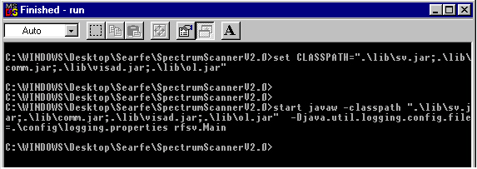

- When the program loads a Spectrum Scanner window will appear.

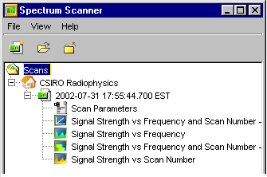

- You can either select to view a scan you have previously made, or start a new scan.

Information on what is meant by the various terms is included throughout these instructions. You will also find recommendations for appropriate settings.

- To start a new scan, click the ‘New Scan’ icon or go to 'File' then 'New Scan'.
- Using the instructions below, set the scan conditions you require in the series of windows that open. Use ‘Next’ or ‘Back’ to move between windows.
Window 1 – Spectrum Scan Conditions.
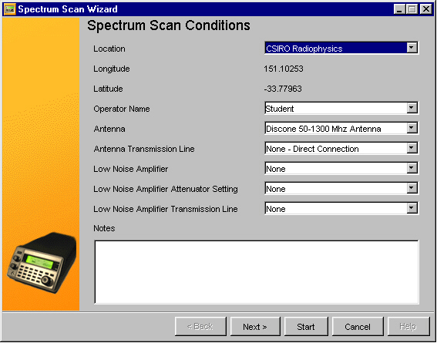

The first window describes conditions external to the receiver. Select the appropriate values for these inputs, either from the list available, or by inputting a new value.

Add any extra relevant notes, which you would like to be recorded with the data file, about the scan you are about to perform. When you have input values for all the variables in this window, press Next to view the next window.

Location: This refers to where the scan is being made in Australia, eg input your school location here, or the nearest location.

Operator Name: Select or type in an identifying name for the operator or team here.

Antenna: Select whether you are using the receiver’s own telescopic whip antenna, the discone antenna supplied or a different antenna.

Antenna Transmission Line: Select whether you are connecting the receiver to the antenna with a cable, and the length of the cable.

Low Noise Amplifier, Low Noise Attenuator Setting, Low Noise Amplifier Transmission Line: These are for a later stage of the experiment. At this stage, these values should be ‘none’.
Window 2 – Set up the AR3000A Receiver
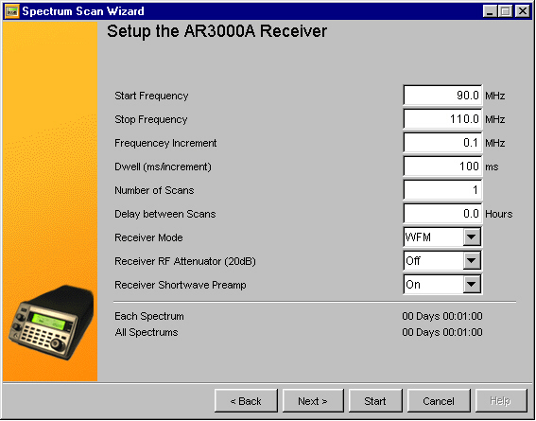

This window allows you to enter the details of the scan you want to make. Input appropriate values for all the variables here.

Note the time that each scan will take and the time that the total number of scans will take. If the time is too long shorten the frequency range to be scanned, or shorten the number of scans and/or the delay between individual scans. When you have input appropriate variables here, the Next button takes you to the next window.

Start Frequency. The frequency at which you want the receiver to start taking measurements.

Stop Frequency. The frequency at which you want the receiver to stop taking measurements.

Frequency Increment. The step size in MHz, which the receiver will step through taking an intensity measurement at each frequency step. Scanning suggestions: For a quick look at a wide range of frequencies, use MODE = WFM, and a frequency increment = 0.100 MHz. For a detailed look at a narrower range of Frequencies, use MODE = AM, and a frequency increment = 0.005 MHz

Dwell. The time for which the receiver will pause between moving to a new frequency and taking a measurement. This should always be at least 50ms to allow the internal receiver electronics time to stabilise.

Number of scans: The number of scans to be recorded one after the other.

Delay between scans. The time delay between completing one scan and starting the next in the series requested.

Receiver Mode. The receiver can be set to different modes, optimised for particular types of signals received. The receiver manual gives the bandwidth and sensitivity of each mode available. Further information on different modes of transmission of radio signals is contained in the Easy Guide – Operating the Receiver and the Receiver Manual.

Receiver RF Attenuator (20dB). This may need to be on in certain circumstances. Leave in ‘Off’ position unless advised to turn it on by the SEARFE mentors. More information about the attenuator and its purpose is available in the receiver manual.

Receiver Shortwave Preamp: An internally switchable shortwave preamplifier (which is active only between 100kHz and 30 MHz) is fitted into the AR3000A and is set to the ‘On’ position. This should be left ‘On’ unless you are advised to turn it off by the SEARFE mentors.

Window 3 - Spectrum Scan Status
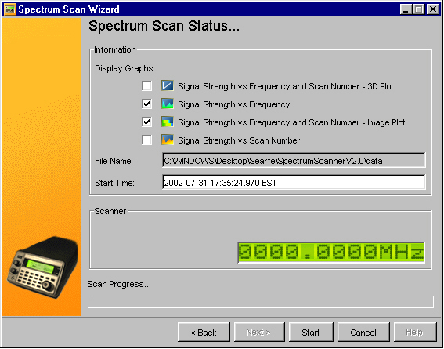

This window describes the progress through the scans you have requested.

Display Graphs - Select which kind of graphs you want to display. These will be displayed as the scan progresses. The 3D graph takes a lot of memory so if it slows the progress too much leave it unselected.

File Name - is set to a default and will be saved in the Spectrum Scan V2\data folder.

Start Time - This is automatically set slightly forward of current time, you can count down to the start of the scan. If you want it to start even further into the future then change the Start Time.

When you are ready to begin scanning, push the Start button. Wait while the computer thinks … If you wish to stop the scan before it is completed, push cancel.
Graph Windows
The graphs will appear on top of each other. Drag the title bar of the top one to move it to the side. Continue this until all graphs are visible if you want to watch them progress. When the scan is complete you can save the graphs as .jpg files if you want to by clicking the 'Save' icon on each graph. The data will automatically be saved for each scan so you can analyse it further later or post it to the SEARFE website for discussion.

You can view the key for the colours used on the graphs by clicking the 'Scale' icon on the top bar of any graph.

N.B. The vertical scale for signal strength is not linear . Each increment of one unit on the vertical scale represents a change in signal strength of a factor of two. This means that for any value, n, of signal strength given on the graph, the actual signal strength is proportional to 2^{n} . This has been done to condense the height of the graphs so that they will fit on the screen.

If error messages appear, check that all the equipment is correctly connected and that the values you have used are reasonable. If you continue to have problems contact the SEARFE mentors through the SEARFE-chat hypermail site.

When the Scan is completed you can close the program by closing all windows using the close button in the top right hand corner.

