Operating the Receiver
When in doubt ask your teacher and refer to the Instruction Manual

First, read through the Manual taking particular note of SAFETY CONSIDERATIONS and proper care of the receiver.
Start-up Procedure
- Attach the appropriate aerial to the rear of the Receiver – Whip aerial or Discone antenna
- Connect to power by plugging the power supply into the 12V DC plug on the back of the receiver.
- Never use a different power supply. Only use the AC adaptor plug provided with the receiver (not the type shown in the Manual).
- Before turning on the power switch, set the VOLUME to zero and SQUELCH to zero (the fully anti-clockwise position)
- Turn on the power source
- Turn on the POWER button on the front of the receiver.

Direct Tuning Instructions
- On the back of the AR Receiver, turn Remote switch to Off
- Using the buttons on the front of the receiver (see diagram opposite) press [DIAL] to allow you to dial a frequency
- Press [MODE] and use the UP or DOWN buttons to select WFM or AM band for the station you want to find e.g. . 702 ABC would be set for AM and Sydney’s 104.1 2DAYFM would be set at WFM
- Press [ENTER] to select this band
- Enter the station frequency in units of MHz using the number keys e.g. 702 ABC station frequency would be [.] [7] [0] [2], Sydney’s 104.1 2DAYFM station frequency would be [1] [0] [4] [.] [1].
- Press [ENTER]
- Increase the VOLUME until you can hear the station you have tuned to
- The SQUELCH knob should stay in the fully anti-clockwise position. If it is rotated clockwise the background noise from the speaker is cut off but this can cause problems with later scans. Turn it to the fully anticlockwise position. This is where it should stay during this project. We call it the zero position.

POWER | 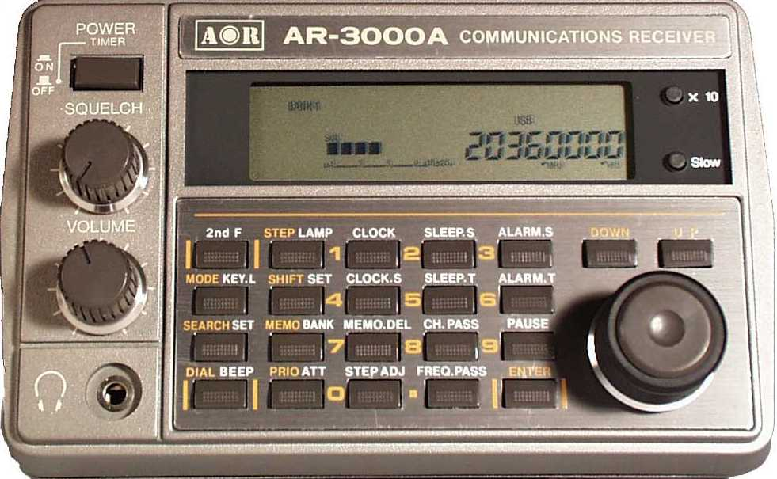 | X 10
SQUELCH |  | UP/DOWN
VOLUME |  | TUNING

 |  | STEP |  | 1 |  | 2 |  | 3
MODE |  |  |  | 4 |  | 5 |  | 6
SEARCH |  |  |  | 7 |  | 8 |  | 9
DIAL |  |  |  | 0 |  | • |  | ENTER

Dial Tuning Instructions
- On the back of the AR Receiver, turn Remote to Off
- Press [DIAL] to allow you to dial a frequency
- Press [MODE] and use the UP or DOWN buttons to select WFM or AM band for the station you want to find
- Press [ENTER] to select this band
- Press [STEP]. The STEP button allows you to enter the rate at which the tuning knob will move through the frequency band e.g. in steps of 0.05 kHz or 50 kHz
- Enter the step size in units of kHz you would like the dial to move in e.g. kHz for AM band [.] [0] [5] [ENTER] to program the tuning knob to move in steps of 0.05. For WFM band this should be set at 50 kHz
- Press [ENTER] to select this Step.
- Enter a frequency (in units of MHz) below your station number e.g. Press [.] [7] [0] [1] [ENTER] for 702 ABC
- Adjust the tuning knob to find the station you are looking for. The tuning knob will move in units of the step size you have selected.

Reset Instructions
When you get into difficulties or press the wrong button
- Press [ENTER]
- Start the procedure again from the beginning
- Otherwise turn off the Power Button and start again.
If all else fails reset the microprocessor erasing all memory contents
- Turn the power switch off
- Press and hold both the [3] and [6] keys and turn the power switch on. Release both the [3] and [6] keys.
The receiver will power up with the factory default settings.

Specifications
Model | AR3000A
Receiver coverage | 100 kHz ~ 2036 MHz
Tuning selection | 50 Hz - 999.95 kHz - programmable
Receiving modes | AM, WFM, NFM, USB, LSB & CW
Number of memory channels | 400 total (4 x 100)
Number of search banks | Four
Aerial connection | 50 OHM BNC
Audio output | 0.7 WATTS 8 OHM load @ 10% distortion
Power requirement | External 12V DC @ 0.5A (nominal 13.8V) negative ground approx.
Size | 138mm (W) x 80mm (H) x 200mm (D) Approx. excluding projections
Weight | 1.2kgs

Some Explanations
Modes:
AM - Amplitude Modulation - most common in LF and MF bands, also used in aircraft communications (108-135 MHz), and some Amateur Radio bands.
WFM - Wideband Frequency Modulation - mainly useful for 88 to 107 MHz broadcast FM.
NFM - Narrowband Frequency Modulation - common for mobile radios in 148-200 MHz area, largely superseded by mobile phones.
USB/LSB - Variations of Single Side Band (SSB) - only used in HF (1.6 to 30 MHz) tuning must be very accurate for SSB to make sense.
CW - Continuous Wave - use to receive Morse code, mainly Amateur bands in HF (around 3.5, 7, 14, 21, and 28 MHz).

Receiver bandwidth
The bandwidth of the receiver is the difference between the highest and lowest frequencies that can be detected at any one time. For instance, if you are in WFM mode, the bandwidth is at least 0.150 MHz, if you are tuned to 102.5 MHz then any signal between 102.425 and 102.575 MHz will be detected. Setting a frequency step of less than half of the bandwidth is usually a waste of time.
Scanning suggestions
For a quick look at a wide range of frequencies, use MODE = WFM, and STEP = 0.100 MHz. For a detailed look at a narrower range of Frequencies, use MODE = AM, and STEP = 0.005 MHz.

